Performance Engineering

*[Subtitle]*

[Document type]

Author: Xingrong Zong

Supervisor: [Supervisor]

Semester: VT21

Course code: 2DV608

Table of contents

1 Introduction 3

2 Calculations 3

2.1 Web Server 4

2.2 Winner Payment Server 4

2.3 Player Engagement Server 4

2.4 Database 5

2.5 Betting Server 5

3 Model 6

3.1 Service Time 6

3.1.1 Web Server 6

3.1.2 Winner Payment Server 7

3.1.3 Player Engagement Server 7

3.1.4 Database 8

3.1.5 Betting Server 8

3.2 Routing Probabilities 9

3.2.1 Router Web Server 9

3.3 Resources 9

3.4 Number of Customers 11

3.5 Response Time 11

3.6 Residence Time 12

3.7 Utilization 12

3.8 Throughput 13

# Introduction

This report shows the results of the mathematical representation of the behaviour from the system proposed, a model created with JMT and the results got by it.

# Calculations

$$T=length of time we observe the system$$

$$A_{k}=number of session arrives we observe for source k$$

$$C_{k}=number of session completions we observe at source k$$

$$B_{k}=total amount of time during which the source k is busy \left(B<T\right)$$

$$N_{k}=X_{k}×R_{k}=average number of jobs in the system$$

$$R_{k}=average source k residence time per job$$

$$λ_{k}=\frac{A_{k}}{T}=arrival rate$$

$$X_{k}=\frac{C_{k}}{T}=throughput rate$$

$$U_{k}=\frac{B_{k}}{T}=utilization$$

$$S_{k}=\frac{B_{k}}{C_{k}}=mean service time per completed job in the system$$

$$V_{k}=\frac{C_{k}}{C}=mean number of visits per completed job$$

$$D_{k}=V_{k}×S_{k}=mean demand time per completed job in the system$$

|  |  |  |  |
| --- | --- | --- | --- |
| **Server** | **S** | **X** | **U** |
| Web Server | 0.03 s | 1.5 | 0.045 |
| Winner Payment Server | 1 | 0.375 | 0.375 |
| Database | 0.08 |  |  |
| Betting Server | 0.199 | 1.050 | 0.2091 |

## Web Server

$$T=5 days=5×24×60×60=432000 s$$

$$C_{1}=648000$$

$$S_{1}= 30 ms=0.03 s$$

$$B_{1}=C_{1}×S_{1}=648000*0.03=19440$$

$$X_{1}= \frac{C_{1}}{T}= \frac{648000}{432000}=1.5$$

$$U_{1}= \frac{B_{1}}{T}= \frac{19440}{432000}=0.045$$

## Winner Payment Server

$$C_{2} = C_{1 }×0.25=648000×0.25=162000$$

$$U_{2}=0.375$$

$$X_{2}= \frac{C_{2}}{T}= \frac{162000}{432000}=0.375$$

$$B_{2}=U_{2}×T=0.375×432000=162000$$

$$S_{2}= \frac{B_{2}}{C_{2}}= \frac{162000}{162000}=1$$

## Player Engagement Server

$$C=2 iterations$$

$$C_{3} = C_{1 }×0.75×C=648000×0.75×2=972000$$

$$S_{3}=400 ms=0.4 s$$

## Database

$$C_{4} = C_{3 }=972000$$

$$V_{4}=\frac{C_{4}}{C_{1}}=\frac{972000}{648000}=1.5$$

$$D_{4}=120 ms=0.12 s$$

$$S_{4}=\frac{D_{4}}{V_{4}}=\frac{0.12}{1.5}=0.08$$

## Betting Server

$$N_{5}=0.265$$

$$R_{5}=0.2525 s$$

$$U_{5}=0.2091$$

$$X_{5}= \frac{N_{5}}{R_{5}}= \frac{0.265}{0.2525}≈1.050$$

$$S_{5}= \frac{U_{5}}{X_{5}}= \frac{0.2091}{1.050}≈0.199$$

# Model

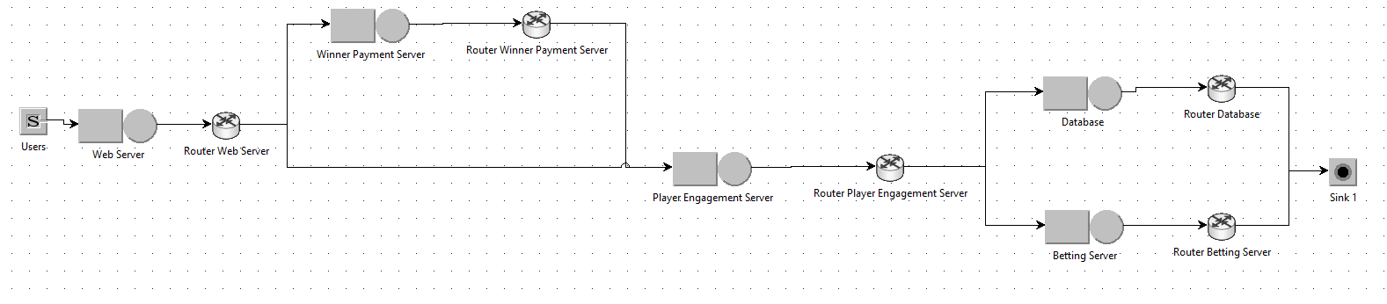

## Service Time

### Web Server

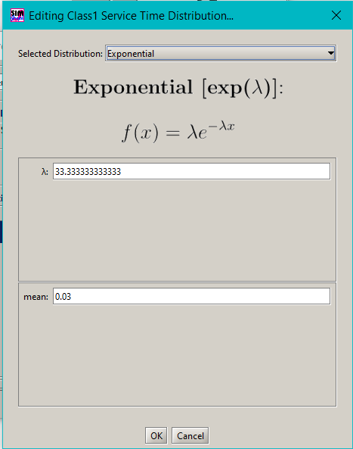

### Winner Payment Server

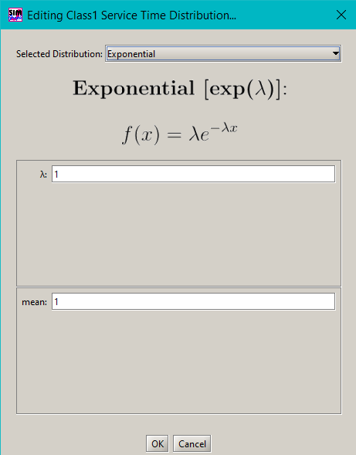

### Player Engagement Server

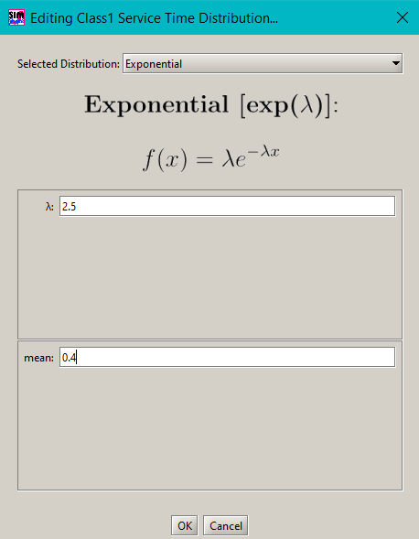

### Database

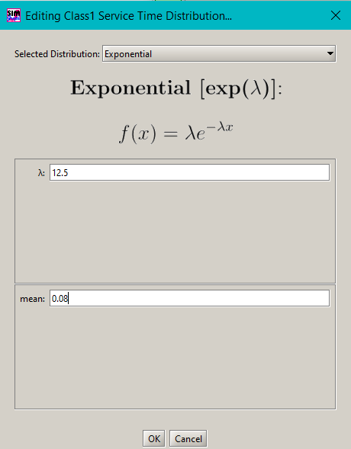

### Betting Server

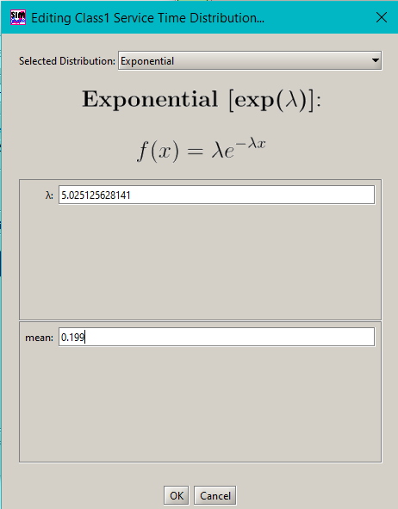

## Routing Probabilities

### Router Web Server

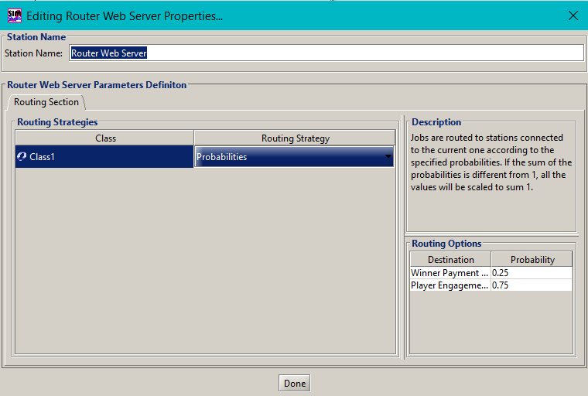

## Resources

Only PlayerEngagementServer has 2 servers working in parallel.

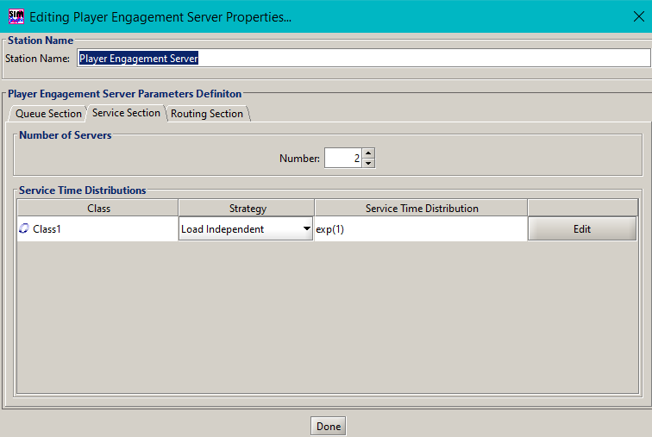

There is no System Response Time to choose in Performance Indices in this version.

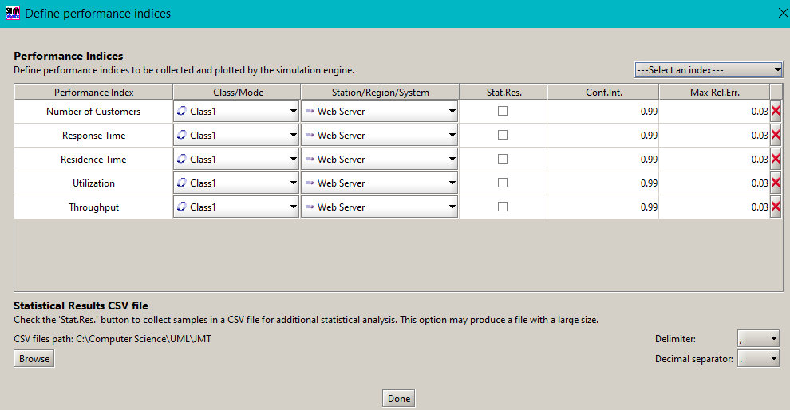

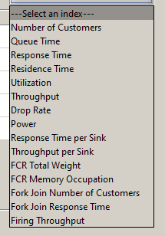

## Number of Customers

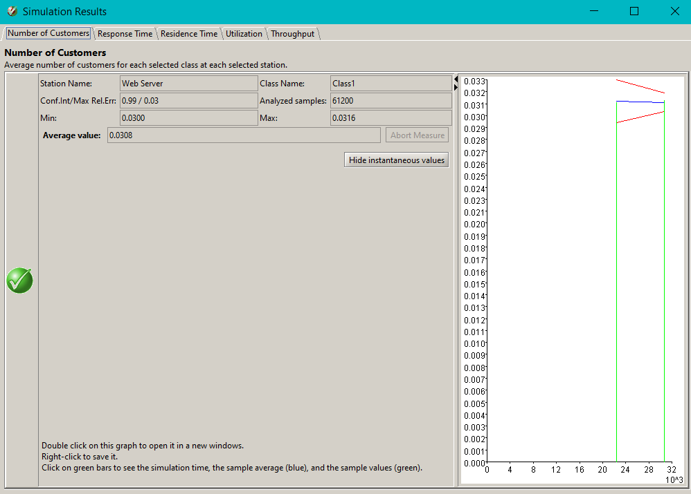

## Response Time

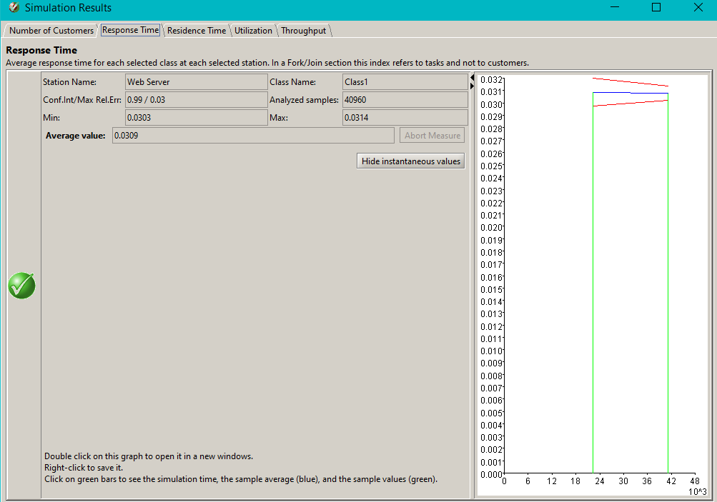

## Residence Time

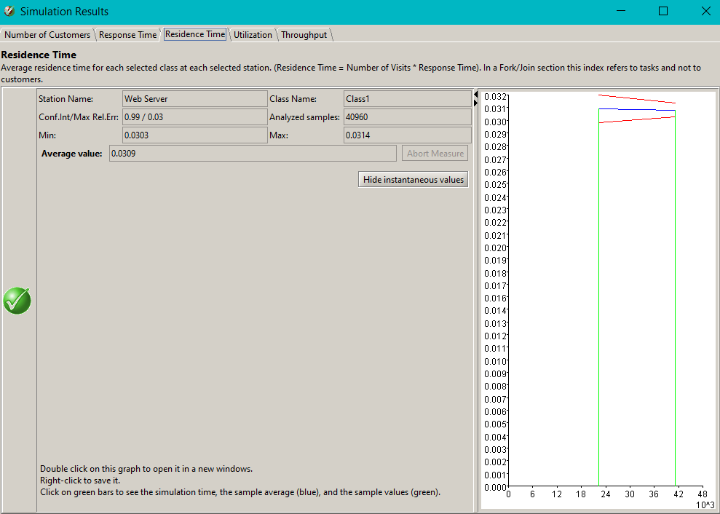

## Utilization

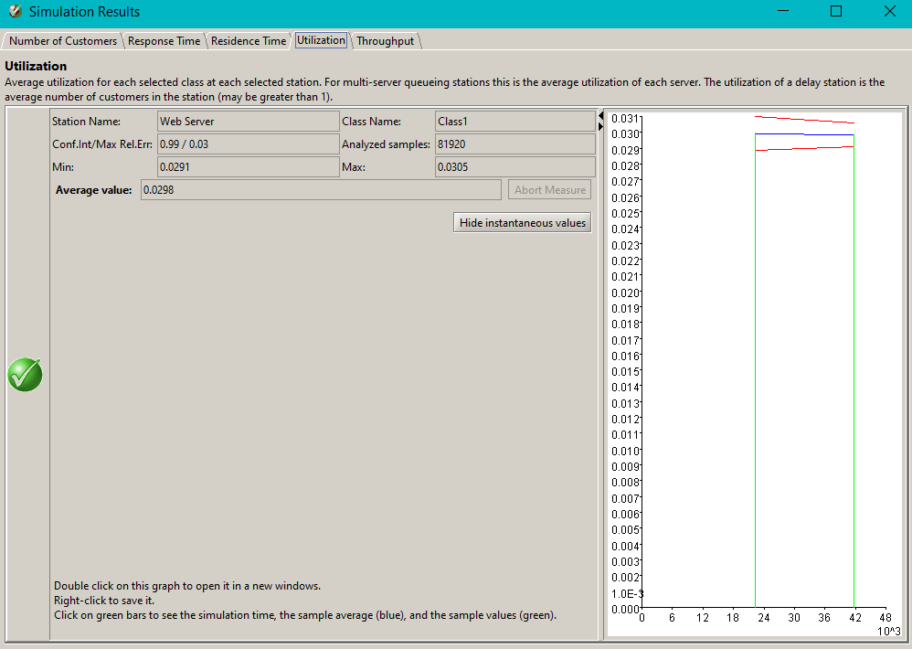

## Throughput

